Logging into Adobe Creative Cloud

Faculty, staff and students now have access to Adobe Creative Cloud. Our new campus agreement allows users to install applications on two computers. If you are interested in a third machine, you can go to varsitybuys.com and place your order. An alternate email address will be needed. If you have trouble logging into Adobe Creative Cloud (adobe.com), please contact the Helpdesk (325.674.4357) or Team 55 (325.674.5555) for assistance.
Here are some helpful links for exploring the Creative Cloud applications:

Inspiring Examples
https://helpx.adobe.com/creative-cloud/tutorials-explore.html
https://www.adobe.com/creativecloud/students/make-it-with-creative-cloud.html

Quick Tutorials:
https://helpx.adobe.com/creative-cloud/student-tutorials.html
http://www.adobe.com/creativecloud/catalog/desktop.html

Finally, remember to check out the Creative Cloud tutorials on Lynda.com:
http://www.acu.edu/lynda

To install Adobe Creative Cloud applications open a web browser and navigate to adobe.com.
Click the "Sign in" link at the top right corner
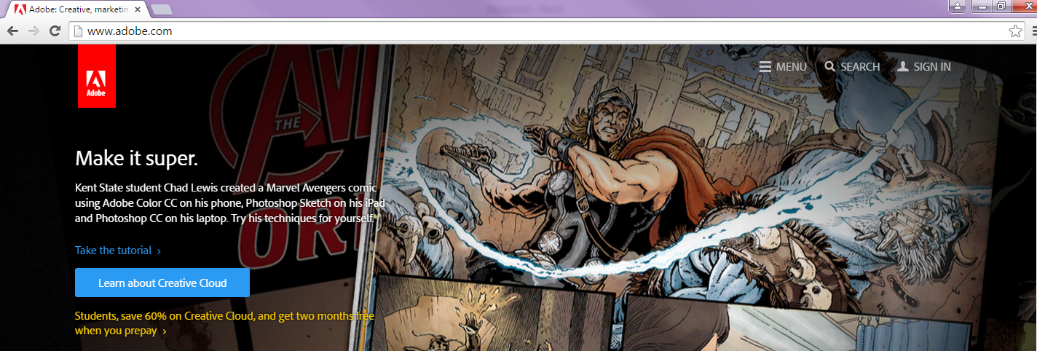

Click the blue link "Sign in with an Enterprise ID"
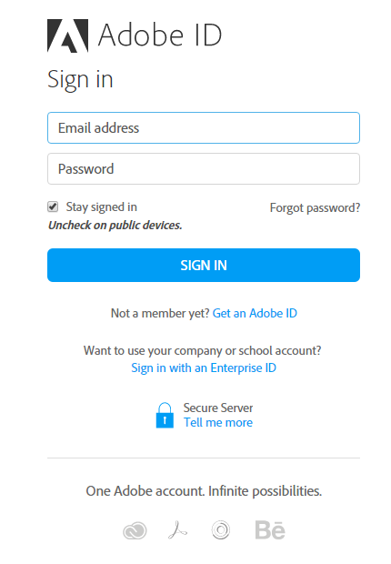
Enter your email address in the first field and click the blue button "Sign in with an Enterprise ID"
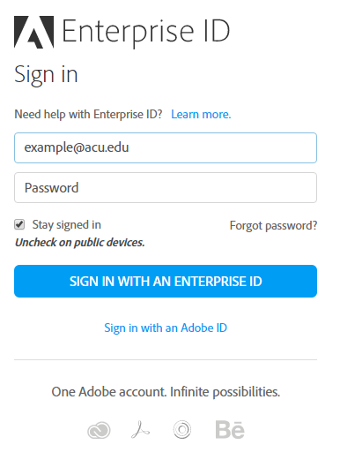

Click Enterprise ID once more if that is a selection visible to you. (You will only see this if you have had an Adobe ID account before.)
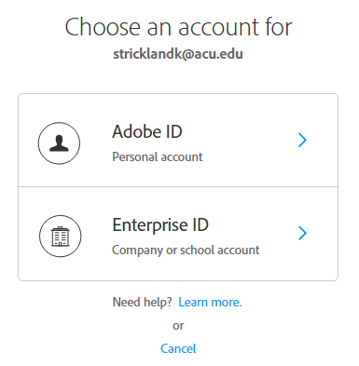
You will be directed to enter your myACU username and password (Single Sign On page).
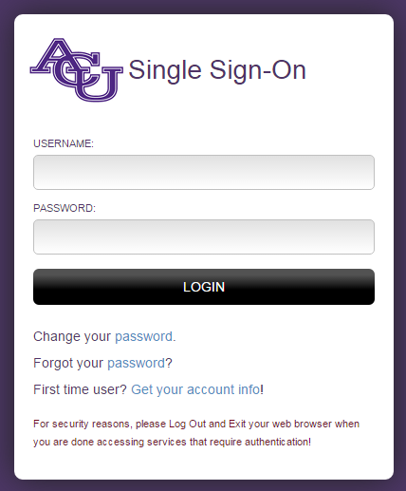

From the left menu, click on Desktop Downloads.
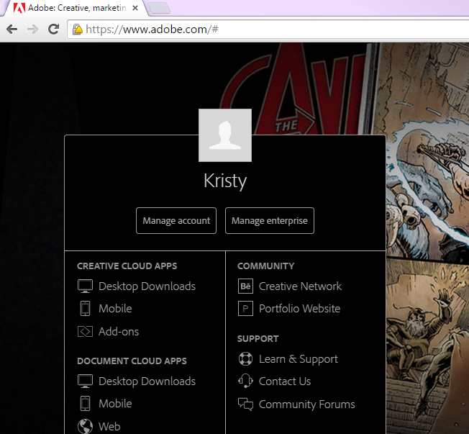

Scroll down and click the download link for any of the products you wish to install.
